REPORT FOR Joint JEC (Mar 2015)

ILAC AND IAF JWGC

This report covers the activities of both the ILAC Marketing & Communications Committee (MCC) and the IAF Communications & Marketing Committee (CMC) since the last General Assembly meetings held in Vancouver.

The ILAC MCC and IAF CMC have not met since the last General Assembly, but will do so in the USA after these meetings.

JOINT IAF and ILAC ACTIVITIES

Strategic Planning

In order to implement the ILAC and IAF strategic plans, the ILAC MCC and IAF CMC have produced a draft forward plan of activity to meet the objectives set out in each plan. The plans have also been shared with the Regional Communications Committee chairs to seek their input. It is hoped that this will share ideas, pool resource and avoid duplication of work.

Events

In order to promote accredited conformity assessment, the ILAC MCC / IAF CMC has presented / is planning to present at the following events:

- Slovenia Accreditation Day (December 2014)
- The WSC (joint IEC, ITU, ISO workshop - Dec 2015)
- WTO Public Forum (October 2015)

In addition, a one-day marketing workshop will take place at the APLAC / PAC Plenary in June 2015.

The IAF Vice Chair will also present publicsectorassurance.org at the STAR meeting in Madrid.

World Accreditation Day 2015

Based on the theme of Accreditation: Supporting the Delivery of Health and Social Care, the Joint Committees produced the following material for members to use:

The materials are available as templates for members to add their own logo and translate into local language. There are online banners on the ILAC and IAF websites to promote the day.

World Accreditation Day 2016

In order to plan for WAD 2016, a TFG group has proposed the following theme:

Accreditation: A global tool to support Public Policy

This theme would allow ILAC and IAF to fully launch and promote the joint Public Sector Assurance reference website. To date, the site has only been promoted within the IAF and ILAC membership with the intention of capturing additional material. This theme would provide IAF and ILAC with a key opportunity to promote this valuable reference tool to its members, as well as to a wider audience.

Publicsectorassurance.org

A joint ISO, ILAC, IAF, IEC and IIOC website has been produced to publish case study examples of how standards and accreditation support government, regulators and the public sector.

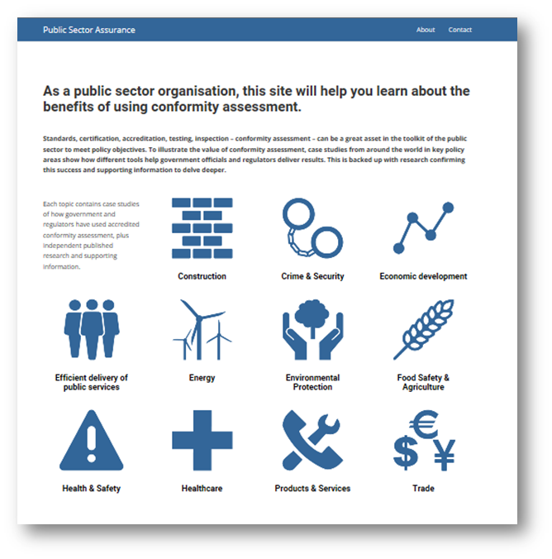
The website has a simple structure with the home page featuring links to 11 different policy areas.

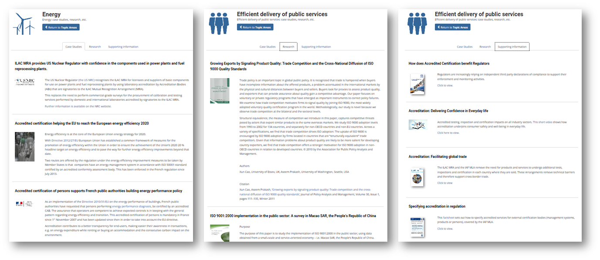

Each policy area contains case studies, supporting promotional material, and external research work.

There are currently 84 different case studies, 35 research papers, and 19 supporting materials. A request has been sent to the Regional Communications Committee chairs to seek additional materials.

Social Media Proposals

In line with the draft ILAC and IAF strategic plans, a proposal was submitted to the ILAC Executive and IAF Executive to recommend that each organisation use social networks as a communications channel. The recommendation proposed the sites to use, the objectives, and the resource requirements.

Counterfeit Certificates

Following a decision in Vancouver, a WG from the JWGC will support the existing TF on Counterfeiting, convened by Ivan Savov. The group will work on the development of the ID on Counterfeit Risk Management, and on a strategy for establishing partnerships, and identifying how to effectively participate in the various global projects and initiatives.

The JWGC has worked to identify potential partners and is researching a list of contacts. It proposed that a target list of contacts is invited to attend either the ILAC/IAF meeting in Frankfurt or Milan.

Annual Reports

The ILAC MRA Annual Report and the IAF MLA Annual Report will be published in May 2015.

IAF CMC

Rules for the Use of the IAF logo

A first draft of the document was reviewed and resulted in a number of changes. It was agreed that the intention of the document should make it clearer and easier to use the logo, however clarity was needed on the types of membership. The CMC agreed to use a model for authorization to use the logo based on a signed form in conjunction with the application for membership of IAF, and that it contain a section that provides examples of typical use. No further progress has been made to date.

IAF Electronic Communications

IAF News was produced by Elva and Krista in February 2015, for which the JWGC passes on its thanks.

This edition was sent to 6269 subscribers, of which 35% (2,222) opened the email.

The software will be used to promote World Accreditation and the IAF MLA Annual Report.

Issue 10 of IAF News will be released after the October meetings.

IAF Website

A total of 128,041 people visited the IAF website during the period. In total the site received 211,214 visits viewing a total of 915,115 pages.

Google search on the site has been upgraded to avoid showing sponsored ads. These typically promote non-accredited services.

ILAC MCC

Promotional Brochures

The ILAC MCC is currently drafting three promotional brochures:
- PT
- RMP
- Calibration

ILAC Website

Following the launch of the ILAC website in August, work has continued (managed by the Secretariat) on the Members Area of the site. This will provide greater functionality such as online voting, and document commenting.

ILAC News

ILAC News was published in October 2014.

The edition was sent to 1,066 subscribers (up from 800).

The latest edition was opened by 45% (483) recipients, as well as being accessed over 1000 times from the ILAC website.

The next edition is due for publication in April 2015.

Consultation responses

Many ABs respond to relevant national policy consultations, however there is also a place for ILAC to respond where it concerns the MRA. While it will serve to support the extended use of accreditation, it also provides a marketing opportunity as responses are usually published online.

In the past 12 months, the ILAC Secretariat has provided a response to the:

- US Coast Guard Agency
- Maryland Medical Marijuana Commission

Revision of R4

Following a comments period, the document has been updated and is ready for ballot. To avoid confusion with ILAC R7, being out for a second round of comments, the ballot for ILAC R4 will follow.

JCTLM Newsletter

Following a Ex decision in Frankfurt 2014, the ILAC MCC agreed to support a key stakeholder, the Joint Committee for Traceability in Laboratory Medicine. The JCTLM are keen to improve the quality of their communications, and so the ILAC MCC has produced the latest edition of their newsletter. This was distributed in March 2015.

Jon Murthy
Chair, ILAC & IAF Marketing & Communications Committee (March 2015)

